Write a short paragraph explaining Bayes’ theorem and why probabilistic reasoning is important in intelligent systems.
P(H∣E) = P(E∣H) P(H)​ / P(E)

Bayes’ theorem provides a mathematical rule for updating beliefs when new evidence is observed. It states that the posterior probability P(H∣E) of a hypothesis H given evidence E is proportional to how likely the evidence is under the hypothesis and the prior belief in the hypothesis.
Probabilistic reasoning is essential in intelligent systems because real world data is noisy and uncertain; Bayesian methods allow an AI model to continuously update its predictions as more information becomes available, enabling robust decision making under uncertainty.

Using the UCI Breast Cancer Dataset, compute (manually or in Python) a simple Bayes posterior probability for one feature (e.g., probability of malignancy given a feature value). Explain your calculation briefly.

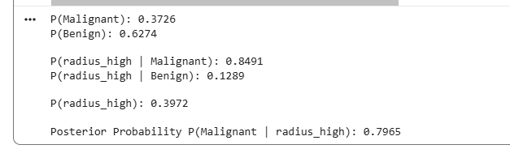

The model uses Bayesian reasoning to estimate the likelihood that a tumour is malignant given a high radius measurement. The prior probabilities indicate that benign tumours are more common in the dataset (P(Benign) = 0.6274) compared to malignant tumours (P(Malignant) = 0.3726).
When considering radius size, malignant tumours show a much higher probability of having a high radius value (P (radius_high | Malignant) = 0.8491) than benign tumours (P (radius_high | Benign) = 0.1289).
The overall probability of encountering a high radius measurement in the dataset is P(radius_high) = 0.3972.
By combining the prior probabilities with the likelihoods, the model computes the posterior probability that a tumour is malignant given that its radius is high. This results in a significantly increased probability of malignancy: P (Malignant | radius_high) = 0.7965, indicating that high radius is a strong predictor of malignancy within this dataset.

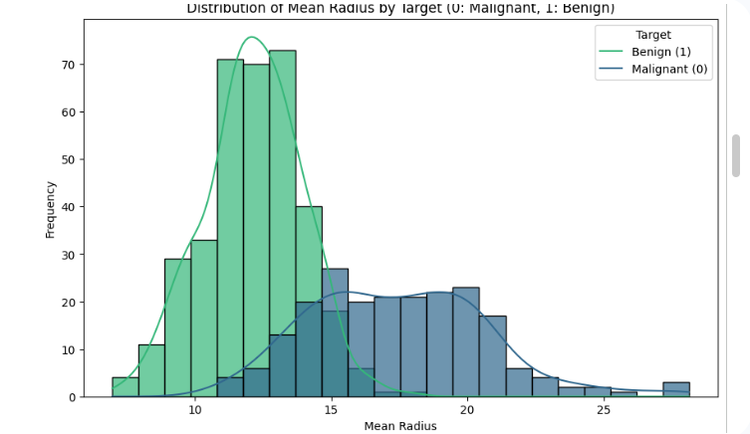
The visualization shows the distribution of mean radius for both malignant (target 0) and benign (target 1) tumours. We can observe that:
- Malignant tumours (blue) tend to have a larger mean radius compared to benign tumours.
- Benign tumours (green) are concentrated at lower mean radius values.
This distinct separation in the distributions suggests that 'mean radius' is a strong indicator for differentiating between malignant and benign cases, which aligns with our previous Bayes' probability calculation where a 'high mean radius' significantly increased the probability of malignancy.

Explanation of Bayes Posterior Probability Calculation
This section describes how the posterior probability of a tumour being malignant was calculated, given that its mean radius is classified as high; above the dataset’s average mean radius
1. Prior Probabilities
P(Malignant) represents the overall probability that a tumour in the dataset is malignant, regardless of any features. It is calculated as the proportion of malignant cases.
P(Benign) represents the overall probability that a tumour is benign.
2. Likelihoods
P (radius_high | Malignant) is the probability that a tumour shows a high mean radius given that it is malignant.
P (radius_high | Benign) is the probability that a tumour shows a high mean radius given that it is benign.
3. Evidence
P(radius_high) is the overall probability that a tumour has a high mean radius in the dataset. It is computed using the law of total probability by combining the likelihood of a high radius within each class with their priors:
P(radius_high) = P (radius_high | Malignant) * P(Malignant) + P (radius_high | Benign) * P(Benign)
4. Posterior Probability
P (Malignant | radius_high) represents the updated probability that a tumour is malignant after observing that it has a high mean radius. This value is computed using Bayes’ theorem:
P (Malignant | radius_high) = [P (radius_high | Malignant) * P(Malignant)] / P(radius_high)
The resulting posterior probability reflects how strongly the presence of a high mean radius shifts the likelihood toward malignancy, combining both prior information and observed evidence from the dataset

Describe what Naive Bayes is and where it is commonly used.
Naive Bayes is a probabilistic machine learning algorithm based on Bayes’ theorem, which calculates the probability of a hypothesis given observed evidence. The naive assumption is that all features are conditionally independent given the class label. Despite this simplification, Naive Bayes often performs very well in practice, especially when the independence assumption is approximately true or when the dimensionality is high.

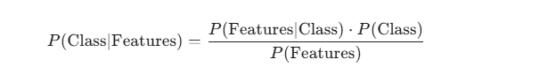
Common Uses of Naive Bayes
- Spam filtering; classifying emails as spam or not spam
- Sentiment analysis; positive, negative, neutral text classification
- Medical diagnosis; predicting disease presence from patient features
- Document classification; topic categorization

Use the UCI Heart Disease Dataset and build a small Bayesian network (using pgmpy, bnlearn, or any tool). Choose at least three features (e.g., chest pain type, blood pressure, age) and show how the network predicts or infers risk. Include a screenshot of the network graph.
Bayesian Networks
Bayesian networks (BNs) are graphical models that represent probabilistic relationships among variables. They use directed acyclic graphs (DAGs) where nodes represent variables and edges indicate direct dependencies. Each node has a conditional probability distribution (CPD) that quantifies the probability of the node given its parents. This structure allows us to infer the likelihood of unknown variables given observed data, handle missing information, and model causal relationships.
For example, using the UCI Heart Disease Dataset, we can model the risk of heart disease using features such as;
- age (numeric or binned)
- cp (chest pain type)
- trestbps (resting blood pressure)
A Bayesian network can model how these variables interact to influence the probability of heart disease.

Explain the core idea of reinforcement learning and how agents learn from rewards
Reinforcement Learning (RL) is a branch of machine learning where an agent learns to make decisions by interacting with an environment. Rather than being told the correct actions as in supervised learning, the agent discovers which actions lead to high reward through trial and error.
The environment provides a scalar feedback signal, called a reward, to the agent after each action. This reward indicates the desirability of the agent's last action and the resulting state.
- Positive rewards are given for actions that lead to desired outcomes, encouraging the agent to repeat those actions in similar situations.
- Negative rewards (penalties) are given for actions that lead to undesirable outcomes, discouraging the agent from repeating them.
The agent's goal is to learn a strategy, or policy, that maximizes the total accumulated reward over time, not just immediate rewards. This often involves a delicate balance between exploration (trying new actions to discover potentially better rewards) and exploitation (using known good actions to maximize immediate rewards).

The Role of Key Components
- Environment: The environment is the external system with which the agent interacts. It defines the rules of engagement, the current situation, and how the agent's actions affect the world. It provides the states and rewards to the agent. The environment can be anything from a simple grid world to a complex real-world system.
- States: A state represents the current situation or configuration of the environment as observed by the agent at a particular moment. It encapsulates all the necessary information for the agent to make an informed decision about its next action. For example, in a chess game, a state would be the current configuration of the board; in a robot navigation task, it might be the robot's current position and sensor readings.
- Actions: Actions are the set of possible moves or decisions an agent can take within a given state. The agent chooses an action from this set based on its current understanding of the environment and its goal. For instance, in a navigation task, actions might include 'move forward', 'turn left', 'turn right', or 'stay'.
- Policy: A policy, denoted as (\pi), dictates the agent's behaviour. It is essentially a strategy that maps states to actions. For any given state, the policy specifies what action the agent should take. The ultimate goal of an RL agent is to learn an optimal policy ((\pi^*)), which is a policy that maximizes the expected cumulative reward over the long run. The agent continuously refines its policy through interaction with the environment, aiming to converge on the optimal behaviour that yields the highest possible rewards.

How RL Works
1. Agent interacts with an Environment
At each time step:
- The agent observes a state s
- It takes an action a
- The environment returns:
  - A reward r
  - A new state s′
This loop continues until the task ends.

2. Learning from Rewards
The agent’s goal is to maximize cumulative future reward, also called return
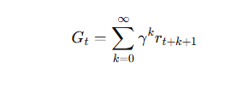
Where:
- Gt​ = return from time t
- γ = discount factor (0 < γ ≤ 1)
The agent updates its policy (decision strategy) using observed rewards.

3. Exploration vs. Exploitation
To learn effectively, the agent must:
- Explore unfamiliar actions to discover potentially better rewards
- Exploit what it already knows to maximize reward
A common strategy: ε-greedy
- With probability ε → take random action
- With probability 1−ε → take the best-known action

References
Domingos, P., & Pazzani, M. (1997). On the optimality of the simple Bayesian classifier under zero-one loss. Machine Learning, 29(2–3), 103–130.
Mitchell, T. M. (1997). Machine learning. McGraw-Hill.
Koller, D., & Friedman, N. (2009). Probabilistic graphical models: Principles and techniques. MIT Press
Kaelbling, L. P., Littman, M. L., & Moore, A. W. (1996). Reinforcement learning: A survey. Journal of Artificial Intelligence Research, 4, 237–285.
Sutton, R. S., & Barto, A. G. (2018). Reinforcement learning: An introduction (2nd ed.). MIT Press.
Watkins, C. J. C. H., & Dayan, P. (1992). Q-learning. Machine Learning, 8(3–4), 279–292. https://doi.org/10.1007/BF00992698
Mnih, V., Kavukcuoglu, K., Silver, D., Rusu, A. A., Veness, J., Bellemare, M. G., Graves, A., Riedmiller, M., Fidjeland, A. K., Ostrovski, G., Petersen, S., Beattie, C., Sadik, A., Antonoglou, I., King, H., Kumaran, D., Wierstra, D., Legg, S., & Hassabis, D. (2015). Human-level control through deep reinforcement learning. Nature, 518(7540), 529–533. https://doi.org/10.1038/nature14236

